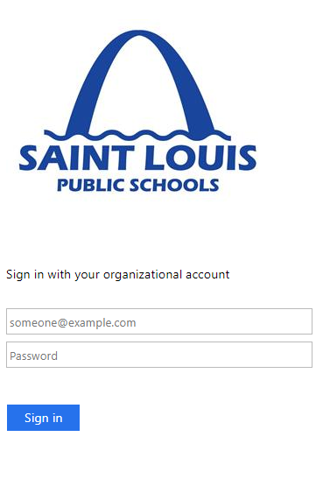

**Microsoft Teams Student Guide**

Microsoft Teams is an online classroom area. Students may use Microsoft Teams to access documents, assignments, class discussions, and/or video meetings with a teacher.

**Access Teams**

1. On a personal computer go to [Miscosoft Outlook Email](https://mail.slps.org/owa/auth/logon.aspx?replaceCurrent=1&url=https%3a%2f%2fmail.slps.org%2fowa) in your web browser (Safari, Chrome, Firefox)

On a personal mobile device download the **Microsoft Teams** app from the store. 🡪🡪🡪🡪🡪🡪🡪🡪🡪🡪

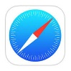

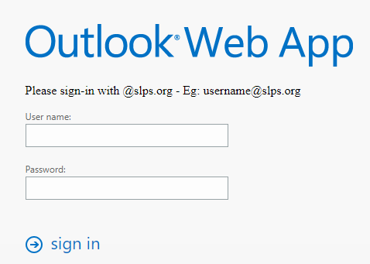On a School issued iPad go to **Teams app**

If there is no Teams app find the **Safari app 🡪🡪🡪🡪**

and access [Miscosoft Outlook Email](https://mail.slps.org/owa/auth/logon.aspx?replaceCurrent=1&url=https%3a%2f%2fmail.slps.org%2fowa). You may see one of the two screens to the right.

2. In the username box enter your first initial followed by the first 7 letters of your last name and the last 4 numbers of your student ID followed by @slps.org (example: George Washington— gwashing1234@slps.org)

Your password is specific to you and was given by your teacher. Email [tfulton2115@slps.org](mailto:tfulton2115@slps.org) if you need your login information (username or password).

3. **On a computer**, you may be taken to a different page where a link appears. Click the link so you can get to your email. Up in the corner you should see a box with dots. Click it and select the Teams app when it appears 🡪🡪🡪🡪

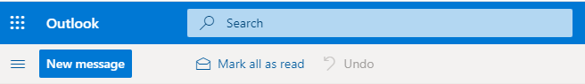



**On a School iPad,** open the Teams app and login with your same username and password. 🡪🡪🡪🡪

****No Teams App?: use two fingers to swipe down. In the top type “teams” in the search bar. When the app shows up, click on it.

Still not working?: Go to LONG TEAMS PAGE in **Safari, 🡪🡪🡪**

and select the “teachers teams pages” tab on the left so you can find your teachers tabs/Teams sites. Click on their site and you should be in!! You may need to login with your SLPS information one more time.